Gion Matsuri

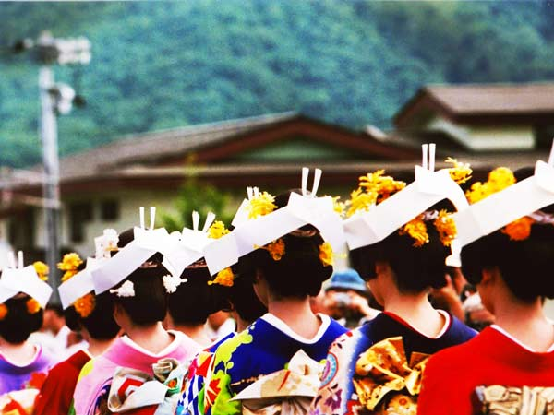

Arguably, this is known as the mother of all Japanese celebrations. This festival began as part of a purification ritual to appease the gods thought to cause fire, floods and earthquakes… Eeps. The event itself is so popular, that it gets celebrated for the whole month of July with something different happening nearly every day. It’s a huge event in Kyoto culture and loved by locals and tourists alike, with the favourite events held on 17th and 24th July. For visitors, the most enjoyable part of the festival is the “Yoi-yama” events held on the three evenings preceding the main float processions. This is when Kyoto really lets loose! If you can lay your hands on a yukata, why not get dressed up and enjoy the fun?

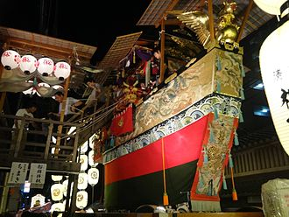

The Gion Festival (祇園祭, Gion Matsuri) takes place annually in Kyoto and is one of the most famous festivals in Japan [1]. Gion Matsuri is one of the largest festivals in Japan for purification and pacification of disease causing entities [2]. It takes place in the month of July on the 17th and 24th.[3] There are many ceremonies held during the festival, but it is best known for its parade, the Yamaboko Junkō (山鉾巡行). The festival takes place at the Yasaka Shrine and the festival gets its name from the Gion district of the city.

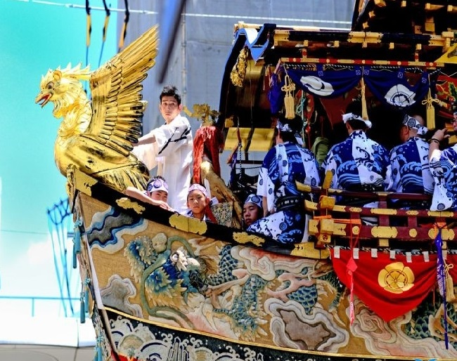

Ironically, the highlight events of Gion Matsuri do not actually take place in the Gion district but rather on the opposite side of Kamo River. During the three days preceding the procession, the respective yama and hoko are displayed within about a half kilometer of the intersection of Karasuma and Shijo streets (see map below). While they are on display, some of the floats can be entered by tourists.

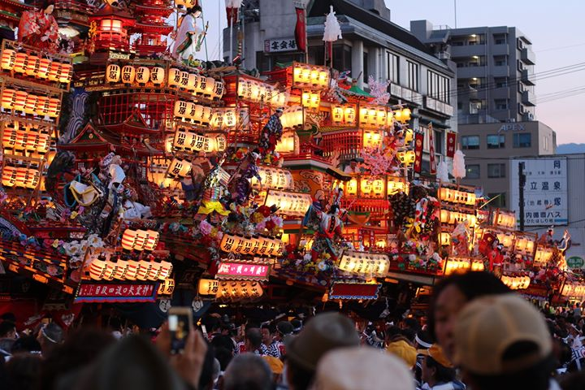

The area becomes most exciting in the evenings, when from 18:00 until 23:00 the streets are closed to traffic and the area swells with food stands, drink vendors and other festival hallmarks. These festive evenings leading up to the procession are known as Yoiyama (July 16), Yoiyoiyama (July 15) and Yoiyoiyoiyama (July 14). Note that road closures in 2019 happen only on the 15th and 16th. Similar festivities also take place on the three evenings leading up to the procession on July 24, albeit on a smaller scale and with fewer road closures and stands.

